Series and Parallel LED circuit
Description:
This project helps students understand how LEDs behave when connected in series and in parallel. It shows the effect on brightness, power usage, and voltage when more than one LED is connected in different ways.

Block Diagram:
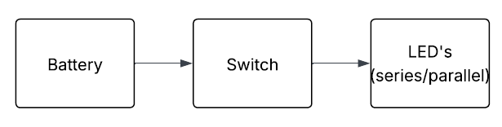
Pinout / Circuit Connection:
Digital Pin: D8 (or any digital pin)
GND: GND pin

Components Required:
• LEDs
• Resistors (220Ω)
• Arduino
• Breadboard (optional)
• Jumper Wires

Working Principle:
In a series circuit, current flows through each LED one after another. This means brightness is usually lower, and all LEDs share the same current. In a parallel circuit, each LED gets the full voltage, so they glow brighter.
Operation (Step-by-Step):
1. Connect the LEDs in series and observe brightness.
2. Then connect the LEDs in parallel and observe brightness.
3. Compare the difference in glow between the the two setups.
4. Understand how current and voltage affect LEDs in each type of connection.

Arduino Code:
Parallel Connection:-
int ledPin = 8; // Common pin for all parallel LEDs

void setup() {
pinMode(ledPin, OUTPUT);
}

void loop() {
digitalWrite(ledPin, HIGH); // All LEDs ON
delay(1000);

digitalWrite(ledPin, LOW); // All LEDs OFF
delay(1000);
}

Series Connection:-
int ledPin = 8; // Series LED string connected to pin 8

void setup() {
pinMode(ledPin, OUTPUT);
}

void loop() {
digitalWrite(ledPin, HIGH); // All series LEDs ON
delay(1000);

digitalWrite(ledPin, LOW); // All series LEDs OFF
delay(1000);
}

Conclusion:
This project helps students clearly understand the difference between series and parallel connections in electronics. It forms a foundation for future projects involving circuits and multiple components.

References:
[1] SparkFun Electronics, “LEDs and Resistors Basics,” Sparkfun.com, 2023. [Online]. Available: https://learn.sparkfun.com/tutorials/leds. [Accessed: 27-Aug-2025].
[2] All About Circuits, “Series vs Parallel Circuits,” Allaboutcircuits.com, 2022. [Online]. Available: https://www.allaboutcircuits.com/projects/series-and-parallel-circuits/. [Accessed: 27-Aug-2025].

